Data Management Plan: Green List for Protected Areas

Prepared by Ellen Martin

Consultant, Green List

January 27, 2020

Contents

Executive Summary 3

I. Green List of Protected Areas Data Management Overview and Objectives 4

II. Data Management Platform Review and Recommendations 8

*COMPASS* 8

*GLIMP* 11

*Interfacing COMPASS with new website* 14

*Other Sources of Green List Data available online* 18

III. Next Steps 21

Appendix 1. Arakwal Data Review Notes 23

Appendix 2. Examples of geospatial data identified on COMPASS for use on GLIMP platform. 29

Appendix 3. Reports and Dashboards to create visualization tools for tracking Green List progress. 31

## Executive Summary

This report includes findings from consultancy work contracted between November 21, 2019 and February 20, 2020. First, data management objectives for the Green List were defined. Next, current status of Green List data was identified by conducting a review of the data platforms housing Green List data (COMPASS, GLIMP, Green List website [in development], and other third-party platforms). Provided in this document are data management recommendations for each platform and recommendations for next steps. Appendices with supplemental information are at the conclusion of document.

Specific questions answered in this report:

What are the applications of Green List data and knowledge?

What are the objectives of the data management plan?

What is the current state of Green List data?

What improvements can be made to the current system of data storage to make it easier for users and better for the application of data to conservation questions?

What are the next steps required to carry out the data management plan?

## Green List of Protected Areas Data Management Overview and Objectives

### *Overview*

Recently, Green List (GL) knowledge management has transitioned from a document and file-based storage system (excel tracking, email communications) to an online database storage system through COMPASS. Two other platforms have been created to complement the Green Listing process: GLIMP (Green List Interactive Mapping Platform) and the new Green List for Protected Areas website. In combination, these three platforms enable sites to join the Green List, explore the ways Green Listing is assisting their protected areas, and to publicly showcase their conservation successes.

Key to success and growth of the Green List as a global certification standard for protected area management is effective use of knowledge. Knowledge on COMPASS should serve multiple purposes: It should be used to determine if Green List indicators and criteria are met and it should be used to improve protected area management locally and globally. Ultimately, the objective of knowledge management for the Green List is to increase the Green List impact on policy and management, increasing breadth, frequency, and potency of conservation successes. To achieve this overarching objective, several internal and external knowledge management goals were identified.

### *Objectives*

Objectives of the Green List Data Management plan:

__________________________

Transition from an exclusively electronic storage system to an   
*interactive user platform* on COMPASS.

+

Facilitate clear, simple Green Listing *progress tracking*   
for sites and jurisdictional EAGLs on COMPASS.

+

Encourage use of COMPASS for data and *knowledge sharing between sites.*

+

Create knowledge interconnectivity with stakeholders, the public, and  
 other *IUCN knowledge tools*.

+

Increase the quality of supporting evidence uploaded to COMPASS (*credibility*)

=   
Increase the number of Green Listed sites who are *joining* and *improving* through the listing process.

=

Create opportunities to showcase how the Green List *provides knowledge benefits* to sites (communications plan).

=   
Increase Green List impact on policy and management = *increase in conservation successes* (breadth, frequency, potency).  
__________________________

Internal knowledge management address how the Green List collects, archives, and retrieves the data it has stored on its databases, within its internal communications, and within the knowledge of its staff (Creech 2004). The Green List internal knowledge management needs specifically concern knowledge used and/or provided by Green List program staff, Green List site managers, and Expert Assessment Groups for the Green List (EAGLs). Internal knowledge management objectives for the Green List are:

1. Transition from an exclusively electronic system of data and knowledge storage to active engagement with the user. Green List program staff and COMPASS/Salesforce staff should provide consistent and effective training materials for all sites on all available tools (COMPASS and GLIMP, e.g., recorded video webinars which can be downloaded). Standardized materials with appropriate language accessibility are important for sites to have equal opportunities to use the tools and to remove barriers (e.g., language, time zone availability, internet connectivity) to the Green Listing process. Interactive platforms currently exist for site managers to communicate and share documents, status updates, and local site news (COMPASS chatter feature). Encouraging continued use of Chatter feature to share updates, successes, and progress tracking will enable site managers to communicate with the GL team, sites to communicate with EAGLs, and sites globally to connect to one another.
2. Create a platform for easy data storage, file uploading, and Green Listing progress tracking. A simplified Green Listing tracking process should be provided for sites to evaluate progress and improvements throughout the Green Listing process, from candidacy phase until approval and listing confirmation. Increasing the ease of evidence upload and increasing the ease with which sites can track their progress will encourage a faster and more interactive Green Listing process. Current features on COMPASS to create visual tools for the Green List exist within Dashboards and Report functions. Appropriate use of these tools to create visualization features will help sites engage with the process and better understand the Green List process.
3. Provide opportunities and tools for data and knowledge sharing between sites. Identify uploaded documents to highlight as successful and outstanding examples of evidence to both acknowledge site achievements and to provide informative examples to other sites of successes in the Green Listing process.
4. Increase the number of candidate sites who are joining and improving through the Green Listing process. Tracking the movement of information from sites uploading evidence, EAGL feedback, and subsequent evidence upload will help sites track their progress and understand the impact of Green Listing on their site management. COMPASS should be a tool which helps sites track their improvements even before successfully receiving a Green Listing certification. Throughout the process, sites should reference COMPASS to receive feedback from EAGLs and improve the quality and relevancy of their evidence.

External knowledge management addresses how the Green List applies and distributes its stored data and knowledge to the public, stakeholders, and the global community. External management objectives for the Green List are:

1. Encourage sharing of knowledge between stakeholders, the public, and other IUCN knowledge products. Linking the Green List information with other IUCN knowledge products will increase Green List saliency. Other knowledge products such as Protected Planet and World Heritage. Linkages through these already-established platforms will increase traffic to Green List webpages and reinforce themes of protected area management for product users.
2. Increase quality of IUCN Green List data and knowledge available to sites and to the public (credibility). High-quality, relevant evidence as uploaded for indicators increases Green List credibility globally.
3. Showcase how the Green List provides knowledge benefits to sites. Use COMPASS to provide information to the newly developed Green List website. Information from COMPASS should highlight Green List site successes and progress. The website is the ‘public face’ of the Green List and should incorporate the best, most compelling data from COMPASS.
4. Increase Green List impact on policy and management (increasing conservation successes): Breadth, Frequency, and Potency.  
   Global visibility and recognition of conservation successes is important for the Green List as it continues to grow and become a flagship program. Growth for the Green List program means increasing breadth, frequency, and potency.

Breadth: e.g., Increase global impact of Green List listing by expanding to include more countries.  
Frequency: e.g., Increase number of instances of Green Listing status referenced for conservation decisions.  
Potency: e.g., Encourage use of Green Listing status to effect significant cultural or conservation changes within protected areas.

These objectives should not be treated as linear objectives to achieve. There is a feedback loop with each objective feeding into and supporting other internal or external objectives. With a platform which is easier to use, saving time and money of sites as they upload their data, we remove barriers for sites to apply for Green Listing candidacy and achieve two objectives simultaneously. Similarly, as sites collaborate and share successes of their high-quality evidence with other sites, IUCN Green List gains credibility and this shared knowledge increases the breath of Green List’s influence.

### *Methods*

Three strategic actions were taken to accomplish this work:

1. Identify and evaluate current status of Green List knowledge.

Identify what evidence we have and how it is being used. Identify strengths and weaknesses in current evidence storage system.

* 1. COMPASS
  2. GLIMP
  3. Website

1. Propose modifications to improve current system.

Propose solutions to save time, money, and increase utility of uploaded evidence and geospatial data.

1. Implement changes and evaluate successes.

Determine best actors to implement changes (e.g., website developers, Salesforce representatives) and evaluate if proposed changes had desired effect.

## Data Management Platform Review and Recommendations

### *COMPASS*

Currently, Green List of Protected Areas data is stored on COMPASS, a Salesforce interface. The goal of the COMPASS platform is to serve as the main platform for Green List participants to complete the Green Listing process. It functions to store all guides, manuals, and relevant documents for sites and EAGLs, and is the main platform of communication between the IUCN Green List team, ASI team, and participants.

Data is uploaded by site managers as *evidence* to provide proof of successful achievement of indicators necessary to be listed as a Green List site. The current process for uploading data requires the site manager to select entire documents to upload and then to subsequently select the corresponding indicator. Data which has been uploaded can be accessed only by designated and approved site-specific users (e.g., Arakwal site users can only access Arakwal data).

Green List site knowledge and data also exist with each sites’ independent data storage system. These data are not shared in the Green Listing process with the other site users, EAGLs, or the Green List team, but is used internally to make site-level conservation and management decisions. Sites do not provide all data, reports, or management decisions to the Green List, either through private communication or through the COMPASS platform. Currently, a site can choose to upload supplemental data unrelated to a specific indicator in the *Chatter* feature. A collaboration with a knowledge tool such as Panorama Solutions gives sites the opportunity to choose conservation successes to highlight without uploading these documents as evidence against specific indicators. Similarly, sites have their own independent geospatial data platforms and data management plans. Consequently, the data used for scientific research, to justify management decisions, and to evaluate conservation successes is almost exclusively housed on independent geospatial data platforms and in internal databases. Data is uploaded to COMPASS addressing scientific research, management decisions, and evaluating conservation successes in a brief summary format.

Sites upload data as required by each indicator: These data most often come in the form of a word document or PDF document and are frequently management plans, governmental legislation, or end-of-year reports (See Appendix 1: Arakwal Data Review Notes). COMPASS currently stores data which contains information to highlight on the website, are an opportunity to extract geospatial data, or are successes to highlight as examples or models for other Green List sites. The Green List team has the opportunity to use COMPASS collaboratively with the other knowledge management platforms (GLIMP, website) to auto populate forms which can pull information onto the websites, generate site summaries, and ultimately highlight conservation successes. COMPASS can also be used collaboratively with GLIMP by housing geospatial data and maps (.pdf format) which can be used as mapping tools and decision-making tools.

After review, the following strengths have been identified in the COMPASS platform. The platform contains comprehensive, high quality evidence uploaded for indicators. Sites are currently uploading and providing evidence of conservation successes, which translate easily to website showcasing. The *Chatter* function on the platform is utilized by many site members to share relevant information and new Green List developments.

Recommendations for COMPASS platform:

1. Training tools and resources:

* Provide consistent and effective training materials for all sites on COMPASS. Current training materials exist as pre-recorded training videos in select languages, scheduled webinars, and live online training sessions. Standardized, downloadable materials with appropriate language accessibility are important for sites to have equal opportunities to use the tools and to remove barriers (e.g., language, time zone availability, internet connectivity) to the Green Listing process. Training videos should be created by Salesforce personnel or GL COMPASS experts.

1. Data upload process:
   * To contribute more information to the website auto populate process, add *Management/Managing Agency* as part of site information entry form on COMPASS. This same information is called *Site Agency* on Site Profiles.
   * During the evidence upload process against indicators, enable sites to specify pages and directly link to pages within uploaded evidence documents (.pdf or .docs) which contain exact reference material. The ability to upload documents and open them to a specific page will save the GL committee and EAGLs time navigating through lengthy management plans or other large documents, subjectively selecting information from the documents to use as the evidence against indicators. With this modification, the same piece of evidence may be uploaded and applied to multiple indicators, but the redundancy of searching through the same document for different information will save time.
   * Some sites are scanning and uploading handwritten data in the form of a .pdf document (e.g., field representatives at Ol Pejeta). Collecting data and providing proper tools to encourage data collection and uploading to the Green List could increase quality of data in the knowledge network.
   * Some sites do not have evidence uploaded against indicators, yet the EAGLs and sites have determined that indicators have been met (e.g., Arakwal). If we create a data visualization tool, this missing evidence can indicate sites have not met requirements when they have just applied the same piece of evidence to multiple indicators.
2. Other features of COMPASS:
   * Missing key collaboration feature for sites to share and find examples of outstanding evidence. As part of the EAGL review, EAGL members should have the option to recommend pieces of evidence as exemplary (tick-box on COMPASS as they review) which triggers an automatic email congratulating sites and asking if their piece of evidence can be made available to other sites as exemplary.
   * Create continuity between Green Listing data and 5-year renewal. Encourage sharing of conservation successes during the time between certification and renewal. A feature in COMPASS should prompt the sites to submit a yearly update, to generate a yearly report, or to contribute a newsletter article/website update at specified time intervals. COMPASS/Salesforce has an underutilized feature allowing sites and GL team members to schedule reminders and tasks. GL team could use this feature to automate reminders to sites that the Green Listing process does not end with listing.

e.g., There have been recent Green List successes under the radar. For example, there was an opportunity to highlight Ol Pejeta’s recent awards for World Travel Market Responsible Tourism and Siddle-Marsden Award.

* + Further explore Dashboards feature to create tools to help sites track their progress visually. We can use this tool to help sites visualize performance, but dashboards are contingent upon first generating reports. Data for this visualization need is all contained within COMPASS reports which can be either manually generated or scheduled to generate (Appendix 3: Reports and Dashboards to create visualization tool).
  + Further explore Reports feature to help sites have records of their progress. The reporting feature is complicated. The GL staff should create templates for sites to go in and generate informative reports so the sites are not responsible for learning how to use this feature from the ground-up. As long as we determine the informative data we want sites to extract from COMPASS, these Reports can be easily created and waiting for sites to use.

### *GLIMP*

GLIMP is a web-based interactive mapping project created by UNEP-GRID Arendal. Currently, data for two sites reside in GLIMP: Van Long Wetland Nature Reserve and Con Dao National Parks. Layers for each site have been uploaded by GRID and trainings (in-person and remote) have taken place at both locations for on-site staff.

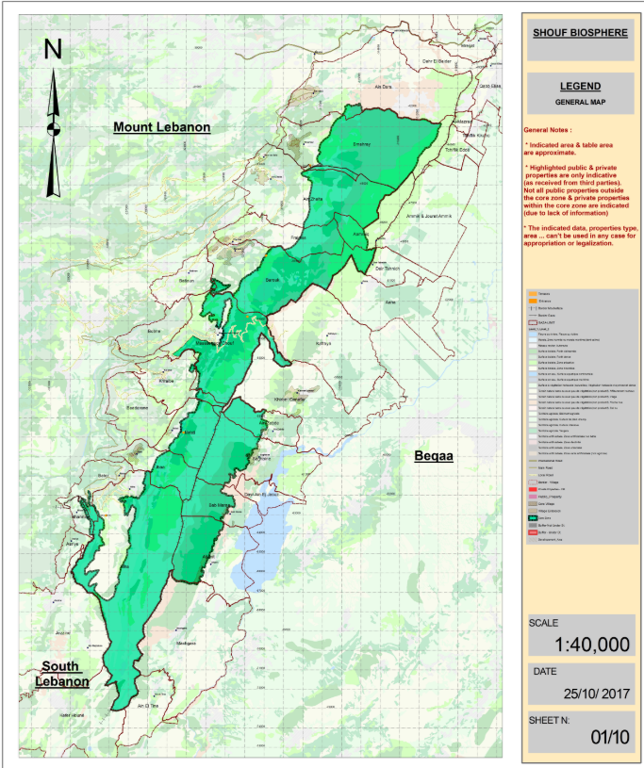Geospatial data for use in the GLIMP platform is acquired independently from COMPASS. Very little data uploaded to COMPASS from the three sites reviewed (Arakwal National Park, Ol Pejeta Conservancy, and Al Shouf Cedars Reserve) could be downloaded and added as a data layer to GLIMP. A large *GIS.rar* file was uploaded as evidence for Al Shouf Cedars Reserve and can serve as an example for how sites ought to upload geospatial data that they want on GLIMP (i.e., consolidated, zipped file with informative geospatial data layers such as roads, boundaries, proposed study sites). Maps uploaded as PDFs to COMPASS could be imported and added to GLIMP as a base layer but would require proper georeferencing and significant labor. Most maps and base layers would need to be pulled from reports or other documents in which they are embedded (Appendix 2).

Figure 1. PDF uploaded as evidence for Al Shouf Cedars Reserve. Example of a site with high on-site GIS capacity.

The GLIMP portal has high value as a communications tool for the public and as a tool to assist jurisdictional EAGLs with their decisions. EAGL members are not required to have geospatial skills. The Green List team should encourage sites to contribute informative geospatial data which will be either uploaded onto GLIMP by Green List/UNEP-Grid Arendal staff or uploaded directly onto the platform by the site. Geospatial data on GLIMP will help EAGL members visualize the area they are evaluating and will assist in the decision-making process.

Green List sites have varying levels of on-site GIS capacity. For sites with high levels of on-site GIS capacity (e.g., Arakwal), the GLIMP interface has lower value as an analytical tool for new applications of knowledge. Conversely, for sites with lower levels of on-site GIS capacity, the GLIMP interface is an opportunity to provide sites basic geospatial ddata management services and to help sites visualize the impact of their management and conservation decisions.

Currently as it is programmed, GLIMP is highly dependent upon professional GIS experts to edit and upload data. Sites are only able to upload and save temporary data on their project maps for use. In order to have a layer permanently added to GLIMP, data needs to be channeled through GRID-Arendal.

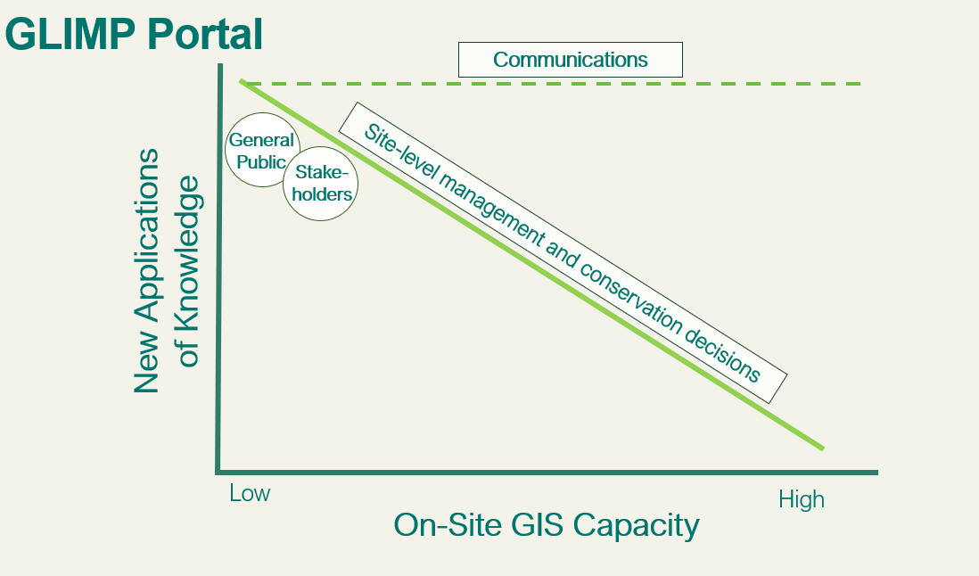

Figure 2. Graph shows high utility of GLIMP as a communications tool with the public, stakeholders, EAGL members, and for sites with low on-site GIS capacity.

### *Interfacing COMPASS with new website*

Information exists on COMPASS which can be pulled to automatically populate the newly developing website. In red below is information which can not be pulled directly from COMPASS.

1. Information and Sources.

Country:

“Countries where PA is located” on COMPASS (Site page).

Site Name:

“Name of PA (in English)” on COMPASS (Site page).

Site Name in Local Language:

“Name of PA (in common regional language)” on COMPASS (Site page).

Listed Year:

“Date Site was added to the Green List” on COMPASS. This is listed on COMPASS as a DD/MM/YYYY entry. Need to just pull out YYYY. (Site page).

Area (km2):

“Area in km2” on COMPASS. Round value up, no decimal places (Site

page).

Designation:

“Designation (in English)” on COMPASS (Site page).

*Note*: There are three separate options for designation on the COMPASS site page. In English, in regional language, and other. Sites do not populate all three.

Marine Protected Area:

“Marine Site?” on COMPASS (None vs Yes; Site page).

IUCN Category:

“IUCN PA Management Category” on COMPASS (Site page).

Website for site:

“Site Website” on COMPASS (Site page).

WDPA ID:

“WDPA ID” on COMPASS (Site page).

Site Agency name (+link to site agency website):

I don’t think this is quite what information you want on the website.

“Ownership Type” on COMPASS.

*Note*: This could be problematic to pull out of compass. For example, Ol Pejeta says “for-profit organisations”.

Site Boundaries:

Not on COMPASS.

Downloadable from WDPA website as a shapefile. Shapefile can be pulled into Mapbox / GLIMP. Can make this file a mandatory part of the site detail page for site managers to upload themselves? Manual process by us.  
WDPA developing new website, may use API to imbed into website proper. May not need boundaries.

Coordinates for Center of each PA: Not on COMPASS. WDPA?

Year site established as a protected area site:

“Year current status was decreed” on COMPASS (Site page).

Site Manager:

“Responsible Contact at Site” or “Responsible Authority Staff” or “Site Mentor” on COMPASS (Site page).

EAGL:

Link back to EAGL page. “Allocated EAGL” on COMPASS (Site page), but it directly links to EAGL page within COMPASS.

Hyperlink within website to link to EAGL informational page.

Media:

Not on COMPASS.

Acquire from Operations Team.

Imbedded Flickr stream.

Download Site PDF:

Not on COMPASS.

Separate generation button.

Site Summary:

“Site Description (in regional language) from COMPASS (Site page).

Do you want it this length or shorter? Shorter: It could be programmed to auto populate from COMPASS and then web manager would go through and edit for clarity/brevity.

Alternatively, could be pulled directly from Site Summary report.

Discussion 11/12/2019:

NS: Ask sites to edit their site descriptions to meet certain requirements.

EM: Two new fields to COMPASS.

“Site Summary for Website (in English)” (emphasize this is for website, set requirements for length and content here).

“Site Summary for Website (in local language)”.

Panorama Solutions Link:

“Panarama Solutions URL” on COMPASS (Site page).

(Incorrect spelling on COMPASS, edit this)

Key Achievements:

A few options to auto populate:

* + - EAGL Conclusion from COMPASS
    - “Site Summary” form which could be on COMPASS.

Manual input:

* + - Site summaries.

Conservation:

Site summaries.

Alternative: We auto-populate with individual indicator justifications and manually cut down from there.

Good Governance:

Site summaries

Alternative: We auto-populate with individual indicator justifications and manually cut down from there.

Community Benefits**:** Site summaries

Alternative: We auto-populate with individual indicator justifications and manually cut down from there.

1. For Consideration.

There are no *criteria*-level summaries on COMPASS for each site. RE: a conversation with Dev, James, and Nadine from Nov 27, how do we summarize data on COMPASS which is targeted towards explaining indicators and scale UP to *criteria-level successes*? Criteria level successes are the most important to highlight on the website. There are opportunities to include visualization tools on the criteria level: For example, if all of the indicators have been met to satisfy criteria one, the graphic indicates 100% completion of criteria one, and 25% overall completion (if other 3 criteria have not been met).

What link do we want between COMPASS and Site Summaries, if any? If Site Summaries are a form on COMPASS, can pull Key Achievements, Conservation, Good Governance, and Community Benefits from that form (*auto populate*). At this point, those descriptions need to be *manually input.*

### *Other Sources of Green List Data available online*

#### Protected Planet Portal

<https://www.protectedplanet.net/c/green-list>

The Protected Planet Portal currently contains minimal text based information, with most of the text-based information focused on the Green List standard and trail phase process with 25 sites. The portal successfully links back to Green List standard online and the Green List IUCN general website. These links will need to be updated with the unveiling of the new Green List website.

On the home page, Protected Planet states that it “provides information about sites that have signed up to work towards the IUCN Green List of Protected and Conserved Areas”. This is misleading information. Protected Planet only provides information about sites that have been accepted and approved as Green List sites.

Information provided on the portal main Green List page contains incorrect information on current countries enrolled in the Green List program. Countries listed as participants are: Australia, China, Colombia, France, Italy, Kenya, Republic of Korea, Lebanon, Malaysia, Mexico, Peru, Spain, and Vietnam. Missing countries such as United Arab Emirates, Jordan, Egypt, etc.

The portal links to a embedded Protected Planet Portal page which has a complete list of Green List Protected Planet sites and map pages (<https://www.protectedplanet.net/search?is_green_list=true>). This page links to 58 sites in total, all currently Green List approved sites.

#### Integrated Biodiversity Assessment Tool (IBAT)

The Integrated Biodiversity Assessment Tool (IBAT), built by United Nations Environment World Conservation Monitoring Centre, is a registered-user mapping and data storage platform and data integrator hub. Currently it contains no reference to Green List. This platform requires users to sign up and subsequently login to use the tools provided. Most users are paying users, but some data layers are available to free subscribers as well.

IBAT interactive map contains links to IUCN Red List, World Database of Key Biodiversity Areas, and World Database on Protected Areas.

From IUCN website re: IBAT

*“IBAT provides a basic risk screening on biodiversity. It draws together information on globally recognised biodiversity information drawn from a number of IUCN’s Knowledge Products: IUCN Red List of Threatened Species, Key Biodiversity Areas (priority sites for conservation) and Protected Planet/The World Database on Protected Areas (covering nationally and internationally recognised sites, including IUCN management categories I–VI, Ramsar Wetlands of International Importance and World Heritage sites).”*

To increase usefulness and incorporation of Green List into data analysis, there is an opportunity to add Green List Designated Site layer to the map interface under the heading of “Protected Areas” map layers.

As a geospatial interface/integration tool, IBAT provides examples of useful data layers that Green List GLIMP platform could also incorporate. Useful layers for both managers to make conservation decisions and for the general public to understand and explore different categories of IUCN management better. Description of available layers (public access) on IBAT:

Sites of Biodiversity Importance

* Key Biodiversity Areas (Alliance for Zero Extinction Sites, Important Bird and Biodiversity Areas, Other)

Protected Areas

* IUCN management category, Governance, Designation

Range Rarity

* “The range rarity, or range size-rarity, map is a ~1km raster layer based on scores for endemism of all mammals, amphibians and bird species. Species range data were rasterised at 30 arc-seconds from IUCN Red List polygons (IUCN 2017). Each grid cell was then scored for range-size rarity for each species. The total score for each cell was calculated by summing scores across all the species whose range overlaps the cell. High values show that an area holds a large number of species and/or that the average ranges of the species present in the area are small, so that the cell represents a relatively high proportion of their range.”

#### MapX / UN Biodiversity Lab

MapX as an online, open source mapping platform offers opportunities for IUCN Green List project hosting and geospatial data sharing. Like IBAT, MapX collaborates with WDPA to provide database users and the public with access to a base layer of IUCN protected area classifications. At a minimum, Green List status can be available through the MapX platform as an additional element to the WDPA IUCN classifications baselayer.

The option to use MapX as a geospatial database integrator for the Green List project is a real consideration. MapX offers the option of uploading own project data and using the analysis overlay tools with the larger available layer dataset. MapX allows users to store both sensitive data and also to make data publicly available.

An option for Green List webpage is to integrate the MapX basemap into the Green List website directly, in a similar way to UN Biodiversity Lab (<https://www.unbiodiversitylab.org/>). UN Biodiversity lab imbeds MapX with the option to turn on and off “themes” relevant to their project goals. Similarly, Green List can have the option to turn on and off layers which relate to each criteria-level success and the appropriate data layers.

#### Other Sources Online of Green List Data Coverage:

Mongabay News

WWF Malaysia

<http://www.wwf.org.my/about_wwf/what_we_do/forests_main/forest_protect/iucn_green_list/>

Brief informational page describing IUCN Green List and partnership with WWF Malaysia, specifically CATS program.

## Next Steps

Immediate next steps for the Green List data management are to implement recommended platform changes (COMPASS, GLIMP, website) and to create the site progress tracking tools in COMPASS. To move forward, the Green List team must connect with website developers and Salesforce representatives to carry out recommended changes. Determine who from Green List team will collaborate most closely with website developers and Salesforce representatives to accomplish the goals of the data management plan and to utilize COMPASS to its maximum potential.

Continued discussion is needed to determine how best to evaluate what successful objective accomplishment looks like and how this success can be measured. The Green List team must determine how to incorporate and evaluate metrics of success such as site satisfaction and feedback, global Green List impact, and influence, etc., in addition to raw numbers of sites listed.

Implementing the data visualization dashboards feature can be done with in-house resources. Next steps required to implement the visualization tools are to first determine the most relevant steps in the process we want sites to achieve and the statistic through which this progress should be communicated (raw count, percentage accomplished, *etc.*). Once important milestones and project tracking goals are identified (see Appendix 3), building and automating the graphic for application across all sites is possible.

Supplemental Information:

* Salesforce contact: Frederic Keller (M: +41 79 940 23 68; Strategic Account Executive EMEA, Non-Profit)
* Salesforce information on generating Reports: <https://help.salesforce.com/articleView?id=reports_formulas_overview.htm&type=5>
* Referenced IUCN knowledge management report:

Creech, Heather. 2004. Mobilizing IUCN’s Knowledge to secure a sustainable future The IUCN Knowledge Management Study. Director, Knowledge Communications, IISD

## Appendix 1. Arakwal Data Review Notes

Blue: opportunity to highlight on website

Red: opportunity to extract geospatial data

Yellow: successes to highlight as examples or models for other GL sites

1. **Site name: Arakwal National Park**
   1. **Indicator 1.1.1.**   
      *“Foundational documents or equivalent containing rules, bylaws, governance structure foundational charters, legislation, agreements, covenant titles, IPAs, policies guiding legislative application”*
      1. Links to most basic sources of information: Websites of sites, founding documents like National Parks and websites/foundational or informational docs. Wildlife Act.
   2. **Indicator 1.1.2.**   
      *“The site's governance structures and mechanisms provide civil society, stakeholders and rights-holders with appropriate opportunities to participate in management planning, processes and actions”*
      1. Data from this is not geospatial.
      2. Evidence here is redundant with evidence uploaded for 1.1.1. Same large documents uploaded for both indicators.
   3. **Indicator 1.1.3.   
      *“****(A) The site's governance structures and mechanisms recognise the legitimate rights of Aboriginal and(B) The site's governance structures and mechanisms recognise the legitimate rights of local communities Torres Strait Islander people”*
      1. Not geospatial data.
      2. Helpful for communities wanting to write their own agreements MOU with tribal land holders. Can reference documents in here as successes of written community agreements.
   4. **Indicator 1.1.4.**

*“Rights-holders and stakeholders are effectively involved in decision-making and the adaptive management of the site. Governance arrangements help advance gender equity in and around the site.”*

* + 1. Evidence here is redundant with 1.1.1-1.1.3 evidence uploaded.
    2. Written comments summarize key points from large uploaded documents and is helpful instead of sifting through all documents individually.
  1. **Indicator 1.1.5.** *“Governance arrangements help advance gender equity in relation to management of the site.”*
     1. This indicator is an opportunity to highlight successes in closing the gender gap between women and men in protected area management. Good to highlight on website, monthly updates.
     2. Evidence uploaded here: Annual Report.
     3. Of note in this report are mentions to the Save our Species project. "Thought to be extinct in the wild for over thirty years, the successful breeding and hatchling release for this frog species is a remarkable achievement hopefully bringing a species back from the brink of extinction. (page 9)”.
     4. There is useful data embedded in these documents. Need better way to highlight these data so that we don’t have to sift through every large document independently.
     5. From report: Growth Centres Biodiversity Offset Program Protected an additional 93 hectares of threatened vegetation in Western Sydney through the purchase of biodiversity credits from biobank sites, bringing the total area protected through the program to 661 hectares of native vegetation at 19 locations.
     6. From report: “In 2017–18, NPWS treated 95,830 hectares, being 1171 hectares of mechanical works and 94,659 hectares of prescribed burning. This represents 71% of the NPWS annual target of 135,000 hectares, which is calculated on a rolling five-year average to take account of variability from season to season.”
  2. **Indicator 1.1.6.**  
     *“The defined governance structures and mechanisms are accepted by major constituents (civil society, rights-holders and stakeholders), reflecting the governance category of the site.”*
     1. Redundant document.
  3. **Indicator 1.2.1.**   
     *“The governance structures and key documents on management are readily accessible to civil society in an easily understandable format. Key documents include the site's management plan or equivalent, relevant subsidiary plans and other key direction documents”*
     1. Evidence of publicly available documents. No geospatial data opportunity.
  4. **Indicator 1.2.2.**   
     *“Where a formal decision-making body exists, the current membership of the body is publically available and procedures for establishment and membership of the body are publically accessible, or: Where there is no decision making body appointed, the names and contact details of formal decision makers such as a Minister or Agency Director are publically accessible”*
     1. Evidence of publically available documents. No geospatial data opportunity.
  5. **Indicator 1.2.3.**   
     *“The outcomes of discussions by decision-making bodies or decision-makers in relation to issues raised by civil society, rights-holders and stakeholders are publically available”*
     1. Redundant evidence here. Uploading same publicly available government webpages. No geospatial data opportunity.
  6. **Indicator 1.2.4.**   
     *“A readily accessible process to identify, hear and resolve complaints, disputes or grievances related to the governance or management of the site is in place”*
     1. Policy management documents uploaded
     2. Redundant documents here/uploaded screenshots of webpages
  7. **Indicator 1.3.1.**   
     *“Procedures are in place to ensure that results from monitoring, evaluation and consultation are used to inform management and planning processes including the establishment of goals and objectives”*
     1. Uploaded tracking document. No data here, but opportunities to upload geospatial data or other data
     2. State of the parks report references other sources of data which contain geospatial data. “Montague Island State of Parks 2018 assessment report.PDF”
     3. Management of Montague Island report, pg 1. Mentions the development of a database “develop a simple, user-friendly database to support program delivery (Rec. 8).” Conservation project database established. **Contains all project spatial data.** ** Sites have independent databases for their spatial data. What is the benefit to IUCN Green List accessing it?
     4. No mention of Green List in the state of the parks assessment report 2018. Important to mention this?
  8. **Indicator 1.3.2.**   
     “*Planning and decision-making recognises relevant conditions, issues and goals at national and regional scales that impact the protected area”*
     1. Methods paper to justify selection of study
     2. Climate adaptation plan – general for NSW, not park specific.
  9. **Indicator 1.3.3.***“The site has, where relevant, considered historical changes and future projections in social, ecological and climate conditions”*
     1. Original plan of management documents uploaded
     2. Outlines management actions for all projects
  10. **Indicator 2.1.1.**

“*The site meets the IUCN definition of a Protected Area and/or is recognised as a 'Conserved Area'”*

* + 1. Foundational documents, governmental acts listed here.
  1. **Indicator 2.1.2.**

*“The site has been listed and correctly assigned one or more of the six IUCN Protected Area management categories, or has been listed as an 'Other Effective Area-based Conservation Measure', and been assigned one of the four IUCN governance types in the U...”*

* + 1. Screenshots of UNEP WCMC pages listing the site. Contains very little information. Centre World Database on Protected Areas (WDPA).
    2. Nothing in this indicator to highlight or incorporate geospatially – only shows protected area boundaries.
  1. **Indicator 2.1.3.**

*The site has a current management plan or equivalent that is used to guide management priorities and activities.*

* + 1. Evidence uploaded: various management plans. List objectives and ranking system for values. “One aspect of these management plans is establishing health check stations (3 to 5) for each value to monitor conditions.
    2. Most documents uploaded for this indicator are management plans for resources, visitors, aboriginals, etc.
    3. Opportunity for geospatial data from these health check stations?
  1. **Indicator 2.2.1.**

*(A) The designated site is large enough and sufficiently connected to other habitats or ecosystems to achieve the goals and objectives for the site's significant values for nature conservation. The designated site is appropriately designed or configured to achieve the goals and objectives of the sites associated cultural values*

* + 1. Environment plans and maps uploaded here.
  1. **Indicator 2.2.2.**  
     *The site is part of an identified conservation network which is designed to meet goals of representation, replication, connectivity and resilience*
     1. Redundant documents**:** management statement uploaded, same maps and docs.
  2. **Indicator 2.2.3.**

*Where a major site value is 'ecological integrity':  
• The site contains an assemblage of native species and ecosystem types that is characteristic of the region, with intact ecological processes and trophic systems  
• The site is large enough and sufficiently well connected to sustain a viable species population and ecosystem processes in the long term  
  
Where a major site value is the conservation of a species:  
• The site contains the full range of habitats required to sustain a viable population of the species or the ecological community in the long term, taking account of all relevant aspects of the species' life cycle (e.g. breeding areas, wintering grounds, safe migration routes)  
• The site is large enough and sufficiently well connected to sustain a viable population of the species in the long term  
• Or, where the species range is too large to be protected within one designated area:  
a) The site is designed to protect one or more critical life history stage for a species. e.g. feeding, breeding, resting, migratory path / bottleneck  
b) The site contains sufficient areas of the key habitats that support the critical life history stage of the species  
c) The site is sufficiently well connected to other protected or managed areas that contain habitats the species needs to complete its life history*

* + 1. “Site justification” but has good info and science that can be highlighted on the webpages.

No actual “data” in any uploaded documents. References made to studies and data collected and summarized results presented. “The site is also close enough to protected areas on the Australian mainland to support ecological connectivity, providing access to resources to support other life stages.”

* + 1. State of the Parks report uploaded here – summaries of good geospatial data.
    2. PDFs of websites – why not have links to websites?
  1. **Indicator 2.3.1.**

*“Major current and potential threats to major natural values and associated ecosystem services and cultural values of the site are identified, understood and documented, and their location, extent and severity described in sufficient detail to enable effective planning and management to address them.”*

* + 1. Emergency action plan, plan of management uploaded again.
    2. Supplemental reports and documents uploaded which serve as good proof for indicator. Sufficient and thorough resources which justify the indicator and are good examples of plans/future reference documents for other sites. Q: How many pieces of evidence can be uploaded here? In theory 15?
  1. **Indicator 2.3.2.**

*“The likely impact of climate change on the major site values has been assessed, understood and documented.”*

* + 1. Management plans uploaded here. Good, thorough plans. Good reference for other sites developing climate change plans.
  1. **Indicator 2.4.1.**

*“The social and economic characteristics of the region that may be affected (positively or negatively) by the site's designation and / or current management have been identified and the location, extent and severity of impact of the site on social and economic characteristics have been described in the management plan or equivalent or otherwise explicitly considered in management of the site.”*

* + 1. Redundant documents, redundant management plans (with amendments) all stored here again.
  1. **Indicator 2.4.2.**

*“The social and economic benefits and impacts have been considered in the development of management goals and objectives for the site in the management plan or equivalent”*

* + 1. 2 redundant documents, one new plan uploaded (integrated business plan).
  1. **Indicator 3.1.1.**

*The site has a current management plan or functional equivalent which includes:  
a) the goals and objectives for management of the natural values and social and / or economic objectives (where relevant) identified in Component 2  
b) the management strate...*

* + 1. All redundant documents.
  1. **Indicator 3.1.2.**

*The site can demonstrate that management activities and regulations are being implemented and are consistent with the management plan (or equivalent)*

* + 1. Redundant documents, management plans, and environmental factors template.
  1. **Indicator 3.1.3.**

*Adequate, functional and safe equipment and infrastructure is available and accessible to staff as appropriate to manage the site*

* + 1. Site has met standard, but there is no evidence uploaded. Even if proof was collected on site by a GL visit or an EAGL visit, documents still need to be uploaded.
  1. **Indicator 3.1.4.**

*The site has adequate numbers of appropriately trained staff, led by an effective management team, to implement all aspects of its management plan in the long term.*

* + 1. Evidence here is Arakwal indigenous land use agreement. Government Act uploaded.
    2. Again another instance where the site has met the standard, but there is no evidence uploaded.
  1. **Indicator 3.1.5.**

*Management efforts support equity, including gender equity, related to site management.*

* + 1. Foundational documents. Site justification here is the most helpful in terms of info to highlight on website, successes, and progress.
  1. **Indicator 3.1.6.**

*Financial constraints are not threatening the capacity of management to achieve the site's objectives*

* + 1. Operations Plan uploaded again (redundant). But new informational documents about financial state, etc.
  1. **Indicator 3.2.1.**

*Strategies and actions to maintain ecological attributes and processes (including natural disturbances) to maintain or enhance the site's significant values are identified and implemented*

TO COMPASS, ADD MANAGING AGENCY ENTRY

## Appendix 2. Examples of geospatial data identified on COMPASS for use on GLIMP platform.



Figure A.1. Al Shouf Cedars Reserve map uploaded to COMPASS (high GIS capacity).

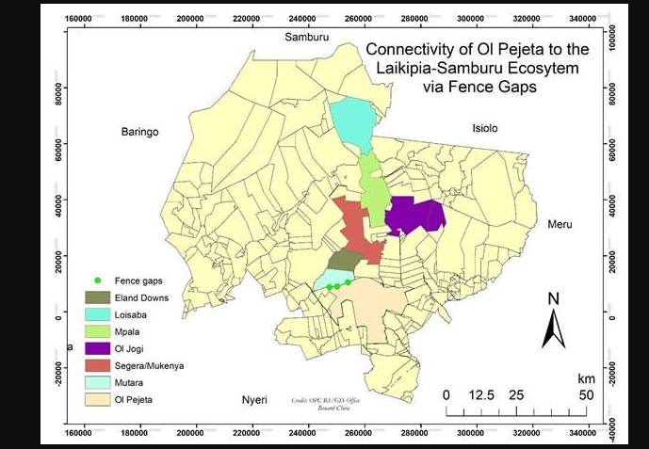

Figure A.2. Ol Pejeta map uploaded as evidence in COMPASS (high GIS capacity).

## Appendix 3. Reports and Dashboards to create visualization tools for tracking Green List progress.

Green List should create visualization tools to help sites track their *overall progress* in the listing progress (have the sites accomplished the major milestones?) and to track their *indicator-specific progress* (has the site uploaded evidence against Indicator 1.1.1.?). Data from COMPASS can be used to build the visualization tools in Reports and Dashboards. Data headings from Site Page on COMPASS to be used to generate these dashboard graphics for progress tracking:

1. Overall Progress:
   1. Application Phase for Site Self-Assessment
      1. Site meets application phase indicators?
      2. Application phase evidence uploaded?
      3. Submitted Applicant for EAGL review?
   2. Application Phase EAGL Confirmation
      1. Application Phase Complete?
   3. Candidate Phase Site Self-Assessment
      1. Site meets Candidate Phase Indicators?
      2. Candidate Phase Evidence Uploaded?
      3. Submit Candidate for EAGL assessment
   4. Candidate Phase EAGL Assessment
      1. Site Visit Conducted?
      2. Stakeholder Input (during Site Visit)?
      3. Submission of Candidate to Reviewer
   5. Candidate Phase Reviewer Verification
      1. Candidate Phase Conforms with Rules?
      2. Submission of Candidate to Committee
   6. Candidate Phase Committee Decision
      1. Site Added to Green List?

__________________________________

Tracking progress post-listing:

* 1. Green List Phase Site Self-Assessment
     1. Mid-Term Site Self-Assessment Conducted?
     2. Site still meets all Indicators?
     3. Submit Mid-Term Self-Assessment to EAGL
  2. Green List Phase EAGL Assessment
     1. Continued Green List Status Granted?

______________________

1. Indicator-specific progress: (binary)
   1. Evidence uploaded for Indicator 1.1.1 (Y/N)
   2. Evidence uploaded for Indicator 1.1.2 (Y/N)

Etc. for all indicators.

Produces visualization which shows % remaining until successful completion of upload process (alternative ways to view the data, doesn’t need to be percent).

COMPASS and Salesforce have tools in the Dashboard feature to help the Green List accomplish their data visualization goal. First step required is to select binary categories which are important for Green List sites to track progress. Fields such as, “Application Phase evidence uploaded? Y/N”, “Candidate Phase Evidence Uploaded? Y/N” options on the Site pages translate to a ticked box (1) or a box left blank (0). After compiling these binary numbers in reports, you can look at individual sites and how many of these “milestones” they have accomplished.

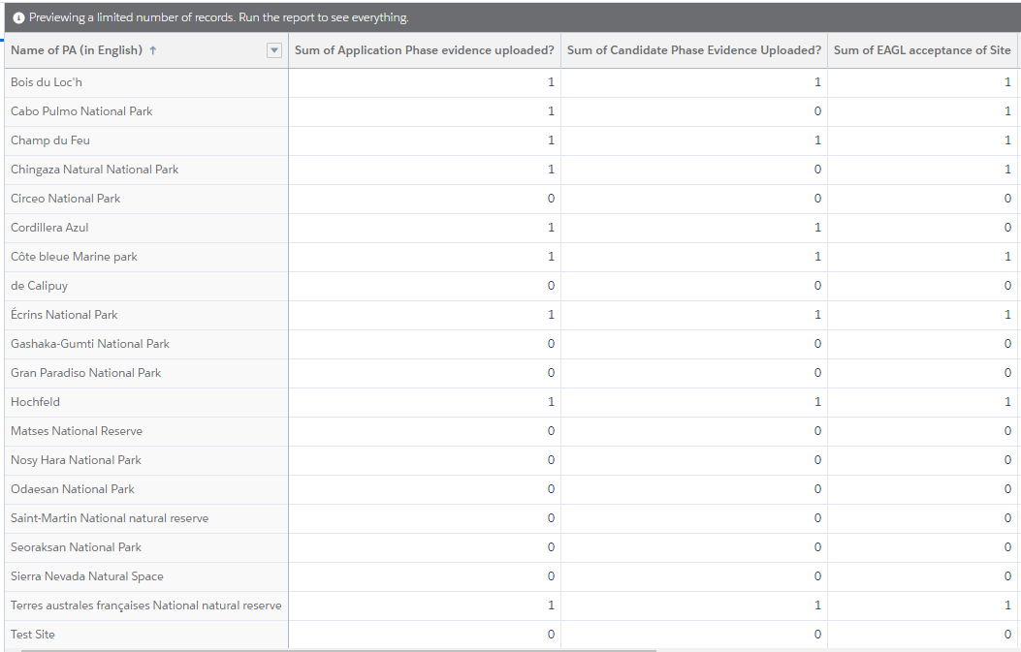

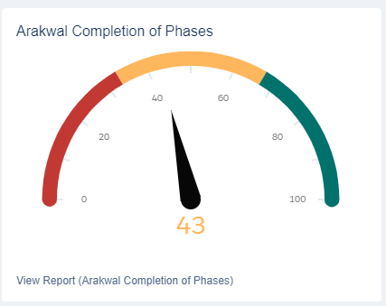Second step is to visualize the report in the Dashboard feature. The Dashboard feature can display data as percentages of boxes ticked (milestones achieved) and the visual can take on a variety of different forms (bar graphs, pie charts, etc.). Creating reports and dashboards for every site to have private access to is possible, but time consuming. Recommended next steps are to reach out to Salesforce professional for assistance automating this process.

e.g.

